Exercise: Analyzing Websites with CRAP

Your Name: Kyler McQuillan

# Overview

So, you've been web surfing for quite some time now, and you've undoubtedly found some pages that you like and others that you don't like. Sometimes, it's not so easy to really explain why. You now have a new vocabulary with which to describe your thoughts on the matter.

# Part 1: Group Evaluations

1. Follow this link using the browser of your choice.

**http://www.rochesterfirst.com/**

1. Examine this site… at least the first page and a couple of links to sub-pages (pages that are part of the same site).
2. Summarize your opinions and why you came to them here:
   1. Alignment:

The text on the screen is center aligned and makes it tough to read nicely. If it is full screen, due to this center alignment, there is a lot of white space on both sides.

* 1. Proximity:

There are very minimal proximity tools put to use in this website. Most of the articles are clumped which makes it easy to skip over some. There are ads very close to content which could mislead a reader.

* 1. Repetition:

The area of highlighted articles looks good. It has a repetitive theme with a bold title, time, and quick description. The picture displayed has the same continued style as well.

* 1. Contrast:

There is a lot of white space on the website and does not have much useful contrast. The content is very bland due to the lack of contrast. Readability is alright.

* 1. Use of color

The color is limited to a lot of blue, black, and white. The amount of white is excessive.

* 1. Use of typography

The font chosen fits for the website. Formal style which is great for news articles.

1. Now go into myCourses, into the **Design Principles** discussion, and tell the class your opinions on the design of **http://www.rochesterfirst.com/**.(HINT: You just wrote them in step 3). Each of you should post your thoughts individually – not as a group.

1. After you post your review, read the other student comments about this site. Choose one other student review and summarize below:

Author of message you’re summarizing: Justin Vaughn

* 1. Alignment:

The only item talked about is the navigation bar, which is stated to look nice and is contained well.

* 1. Proximity:

Articles are stated to fit together in a fair manner, and nearby each other.

* 1. Repetition:

Things are repeated.

* 1. Contrast:

Contrast is good on the website, but the ads are not distinguished.

* 1. Use of color:

Monochromatic accent with a choice of blue.

* 1. Typography

Readable layout.

1. Do you agree or disagree with this person about the design elements of the page in question (Why?)

I agree with Justin on a few elements, but not all of them. For alignment, I believe the navigation bar is holding too much information which makes it look cluttered. The proximity of different articles is rather jumbled and at the top is just way too close together. I agree that the ads are not necessarily distinguishable. Blue being the only accent color seemed very unattractive. The font was a good choice.

1. Reply to their post (politely) to discuss your agreements and disagreements.

# Part 2: Design Critiques

Pick a web site ***you don’t like*** (in terms of design), and a web site you ***do***, and describe/critique each using the forms attached to this handout. If you are having trouble finding a bad site, try using a random link generator such as:

http://www.uroulette.com/ or   
http://www.whatsmyip.org/random-website-machine/

# Part 3: Individual Critiques

Pick a color scheme for your own class page and describe it below. (Describe your color scheme in terms of what color(s) you will use for each element.) Feel free to make these determinations as a team with your neighbors in class.

Background colors will be a deep purple combination.

Text will be white to show up nicely against the purple.

Accent color will be gold to compliment the purple.

Now, use the space below to sketch an improved layout for your page. Again, work with your neighbors to come up with something really great! A simple wireframe drawn up in the app of your choice, or a hand sketch either scanned or photographed with a phone would be fine.

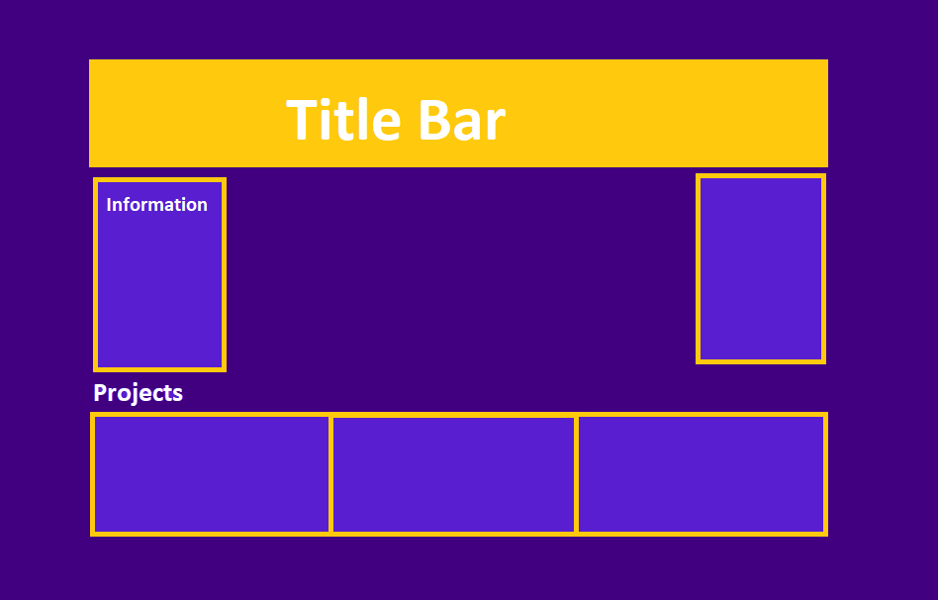

|  |
| --- |
| **bad site:** [**https://co.richmond.va.us/**](https://co.richmond.va.us/) |
| **Alignment:** How many different styles of alignment can you see on this page? Describe them:  Text is centered for the side tabs, which have terrible padding. The search bar seems out of place. The padding in upcoming events is too small. There is clearly 3 columns of information.  Where is the strongest alignment line on this page? Why?  The tabs at the top of the page for different pages since they stand out nicely. |
| **Proximity:** Identify two elements of this site that, due to their proximity, appear to have a relationship. Online Services and Budget, Audit, & CIP sections are both a giant red tab as well as a few other sections on the left side of the screen.  Identify information at this site that "hangs" alone. The Facebook link is off to the side on the left and stands out due to font/color difference. |
| **Repetition:** Does the repetition on this page draw attention to anything particular? What?  The side sections seem to have the same organization. The big red tabs are big red tabs, the events section has listed events in order of date then title, and helpful links is a large bullet list of different links.   Describe the repetitive element(s) used to the best advantage on this site. |
| **Contrast:**  Identify the strongest area of contrast at this site  The helpful links section is nicely organized and has a nice color mood. The difference in color is good between the different sections, just a little much.  Are there areas of this site that seem "muddy" or run together because of a   lack of contrast? What are they?  The center of the page where the main description resides is the only place that has black text on white background, making it the least appealing area even though it should be the most appealing. |
| **Color & Type:**  Does the use of color and type on this page enhance or detract from   the content? How?  There is way too much blue on the website. On the side margins, the title block, the calendar, and even in the pictures since they all have water. Text choice is alright besides titles having a different font. Too many color contrasts. |

**Additional Notes:**

|  |
| --- |
| **good site:** [**https://www.bungie.net/**](https://www.bungie.net/) |
| **Alignment:** How many different styles of alignment can you see on this page? Describe them:  The front page has a big picture showing the newest addition/discovery to the game.  On side pages, there is center aligned clickable pictures, but text is all left-aligned. The center aligned images fit well since they are enlarged and only hold a category/title and not information.  Where is the strongest alignment line on this page? Why?  Everything is organized according to importance and relativity. |
| **Proximity:** Identify two elements of this site that, due to their proximity, appear to have a relationship.  There are multiple areas to the main page. The first is the most important and recent update, then there is the latest hotfix as well as two rewards and downloadable content information. Then there is the latest news section, and in this there are farther outdated articles that appear smaller.    Identify information at this site that "hangs" alone.  On the right hand side is Bungie’s latest twitter posts. |
| **Repetition:** Does the repetition on this page draw attention to anything particular? What?  The hotfix symbol appears often which shows that the team is consistently working hard to improve the game’s current state and fix any problems.   Describe the repetitive element(s) used to the best advantage on this site.  The dating and numbering is used very efficiently. Hotfixes are labels with the specific update number at the end, and “This week at bungie” articles all have the date for that article in the title. |
| **Contrast:**  Identify the strongest area of contrast at this site.  The difference between the various sections. There is featured news, then latest, then later, each one decreasing in size.  Are there areas of this site that seem "muddy" or run together because of a   lack of contrast? What are they?  None. |
| **Color & Type:**  Does the use of color and type on this page enhance or detract from   the content?  The dark style is very appealing to the eye since most images from the game are darker as well. All article images and text are lighter which gives a very nice feel. |

**Additional Notes:**

When you're all done, post this completed file, renamed **Exercise-CRAP-YOURNAME.docx**, to the appropriate drop box before next class.